Assignment 1.1
To import Acadgild VM into your Oracle virtual box
Step 1:Open the virtual box and then follow the below steps:
Click on File --→ Import Appliance.
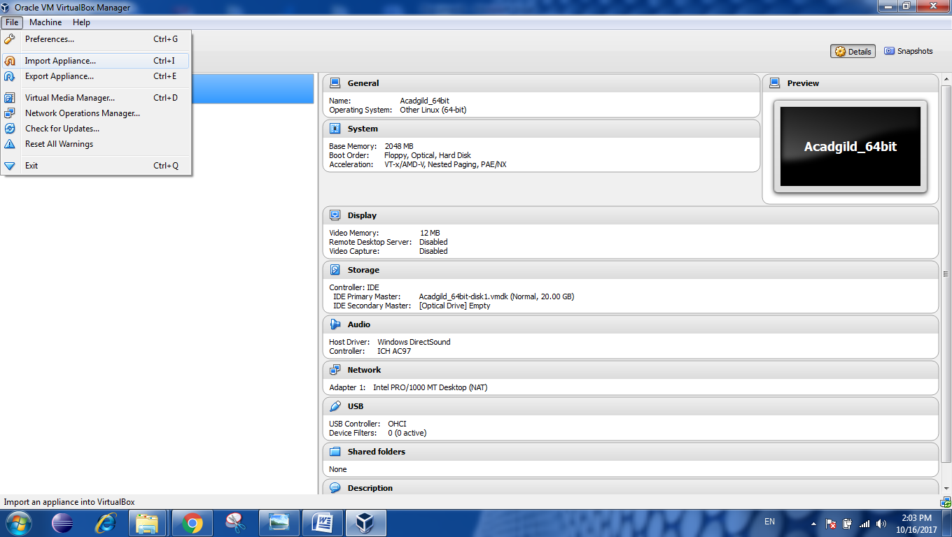

Step2: After clicking on the import appliance we will get a tab open to select the ovf file and enter

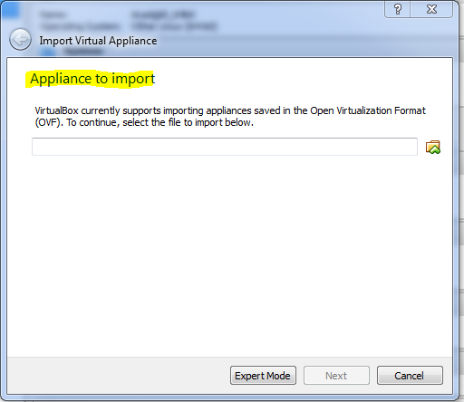

Step 3: After we get the tab we will select the ovf file where we have kept ot or downloaded the file from there we select it.

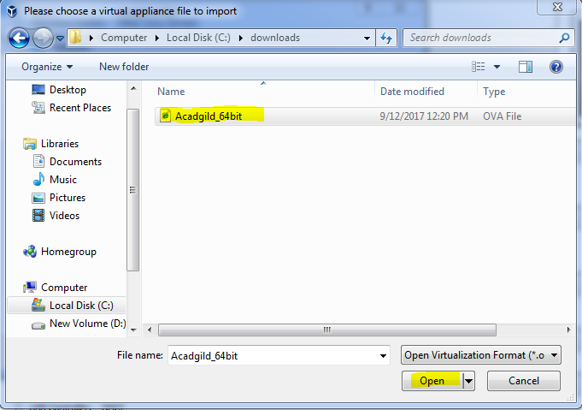

Step4: After selecting click on open and then click on Next tab to get the ovf file there.

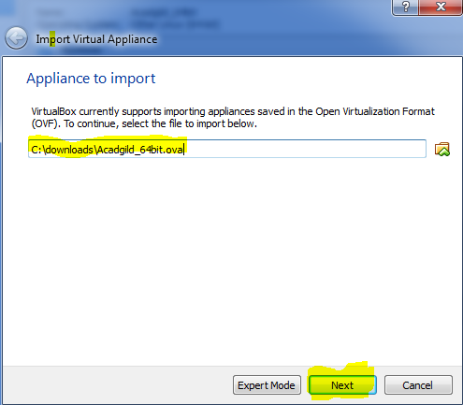

Step5:Goto Appliance Setting and click on import.

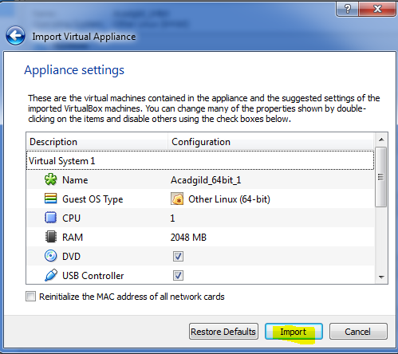

Step6:Now the import will start and will get downloaded.

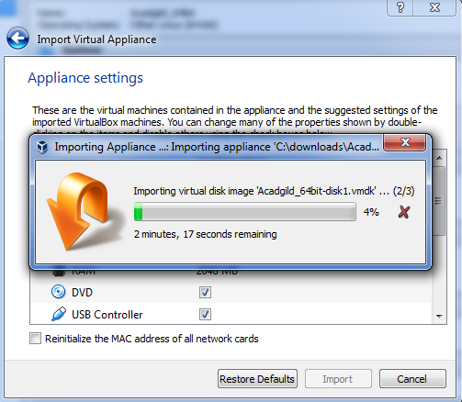

Step7:Once the import will over /Finish click on the Acadgild_64but and the select it and click on start.

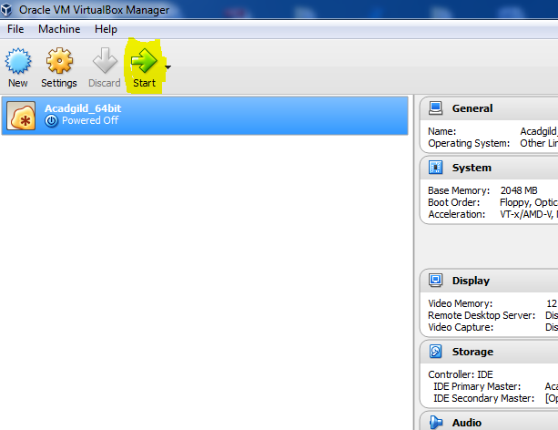

Step9:As we click in start it will open the acadgild and will ask for password will give the password and clicl=k on login.

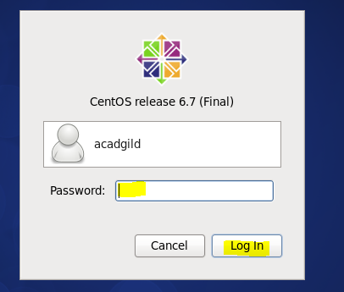

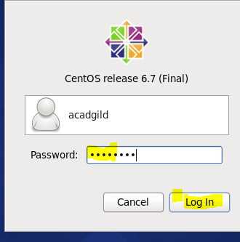

Step10: now open the terminal by clicking on it.
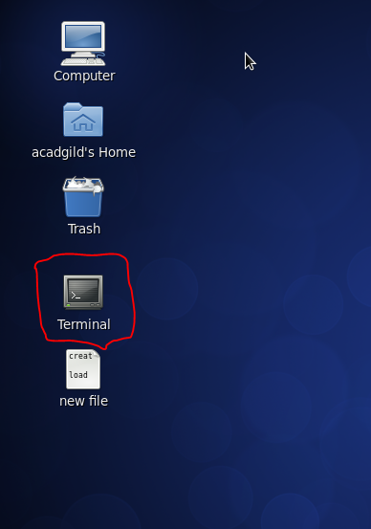

Step 11:jps →command is used to check all the working servers.
Open the terminal and type the command jps to
check the list of daemons, we need to start all the
daemons for the first time.
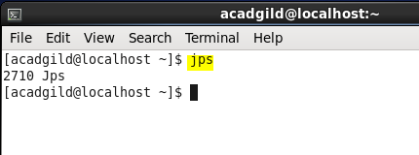

Step12: Open the terminal and start the ssh server.
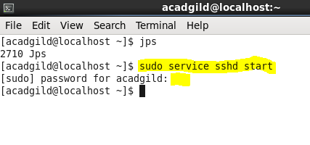

Step13: Start all the daemons.
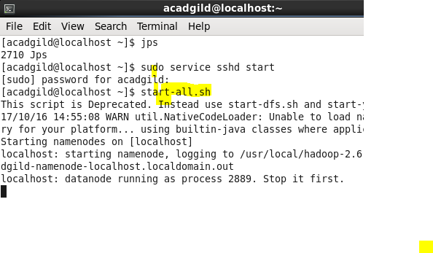
Step14: Start the historyserver:

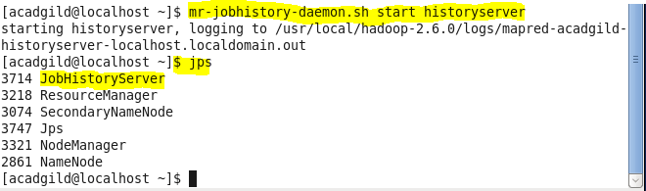

Step15: To start pig in hdfs mode ,type the command pig in terminal.
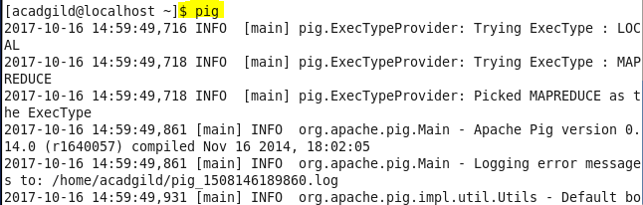

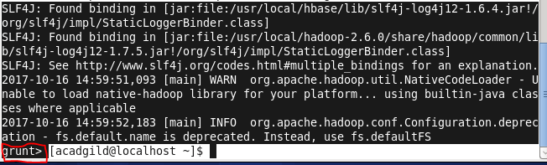

Step16: To start hive first start mysql service and then type
the command hive.

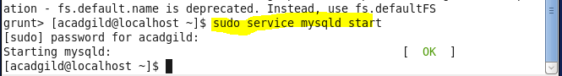

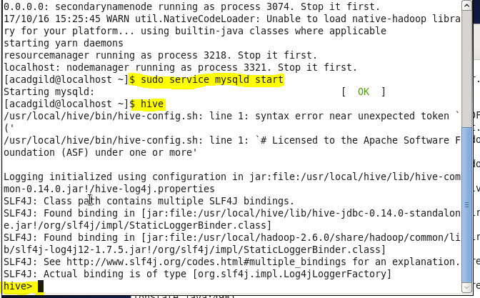

Step17: To start hbase type the below command as shown in
the below screenshot.

